

NAME – Aniriuddha Pratap SinghPRN :25070122247 Batch – C2 COURSE – JAVA

Experiment 9-
Write a Java program to demonstrate the use of the final keyword with variables, methods, and classes.
AIM – Write a Java program to demonstrate the use of the final keyword with variables, methods, and classes.
Program 9
// Program to demonstrate the final keyword in Java
// Final class (cannot be inherited)
final class College {
void displayCollege() {
System.out.println("College Name : SIIT Pune"); }
}
// Parent class
class Animal {
// Final variable (constant)
final int MAX_MARKS = 200;
// Final method (cannot be overridden)
final void sound() {
System.out.println("Animal makes different sound"); }
void displayMarks() {
System.out.println("Maximum Marks = " + MAX_MARKS); }
}
// Child class
class Dog extends Animal {
void displayDog() {
System.out.println("Dog barks");
}
/*
// This is NOT allowed because sound() is final. // Uncommenting it will give a compile-time error.
void sound() {
System.out.println("Dog barks");
}
*/
}
// Main class
public class FinalKeywordDemo {
public static void main(String[] args) {
Dog d = new Dog();
d.displayMarks();
d.sound();
d.displayDog();
College c = new College();
c.displayCollege();
}
}
Output
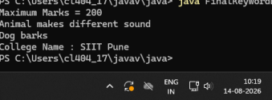EXERCISE
9.1 . Create a Bank Account program where account number is final and cannot be changed
Program 9.1 -
class BankAccount {
// Final variable
final int accountNumber;
String accountHolder;
double balance;
// Constructor
BankAccount(int accountNumber, String accountHolder, double balance) { this.accountNumber = accountNumber;
this.accountHolder = accountHolder;
this.balance = balance;
}
// Method to display account details
void display() {
System.out.println("Account Number : " + accountNumber);
System.out.println("Account Holder : " + accountHolder);
System.out.println("Balance : Rs. " + balance);
}
public static void main(String[] args) {
BankAccount account = new BankAccount(
123456789,
"Sourabh Gupta",
25000
);
account.display();
// account.accountNumber = 987654321;
// Error: cannot assign a value to final variable accountNumber
}
}
Screenshot 9.1 –
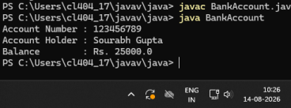
Program 9.2 - Create a Library Book Management program where the book ISBN is declared as final and cannot be changed once assigned. Display the book's ISBN, title, author, and price.
class LibraryBook {
// Final variable
final String ISBN;
String title;
String author;
double price;
// Constructor
LibraryBook(String ISBN, String title, String author, double price) { this.ISBN = ISBN;
this.title = title;
this.author = author;
this.price = price;
}
// Method to display book details
void display() {
System.out.println("ISBN : " + ISBN);
System.out.println("Title : " + title);
System.out.println("Author : " + author);
System.out.println("Price : Rs. " + price);
}
public static void main(String[] args) {
LibraryBook book = new LibraryBook(
"978-81-12345-67-8",
"Java Programming",
"James Gosling",
599
);
book.display();
// ISBN cannot be changed because it is final
// book.ISBN = "978-81-98765-43-2";
}
}
Screenshot 9.2 –
